WEEK 2 TASK
Exploratory Data Analysis & Visualization
Hotel Booking Demand Dataset
Prepared by: Ashutosh Kumar
Tools: Python, Pandas, Matplotlib, Seaborn
Dataset continuity: Week 1 cleaned Hotel Booking Demand dataset

Executive Summary
This Week 2 project extends the Week 1 preprocessing workflow into exploratory data analysis (EDA). The purpose is to summarize the cleaned hotel-booking data, compare the two hotel types, investigate cancellation behavior, examine seasonality, inspect booking lead time and pricing, and identify relationships among numeric variables.
The public dataset contains 119,390 booking records and 32 original variables covering a city hotel and a resort hotel. Public analyses report 79,330 city-hotel records and 40,060 resort-hotel records. The overall cancellation rate is approximately 37.04%, with the city hotel at about 41.73% and the resort hotel at about 27.76%.

1. EDA Objectives
- Understand the distribution and scale of the cleaned dataset.
- Compare booking volume and cancellation behavior between hotel types.
- Identify seasonal demand patterns by arrival month.
- Understand booking lead-time behavior.
- Compare Average Daily Rate (ADR) across hotel types.
- Examine market-segment concentration.
- Investigate correlations among important numeric variables.
- Translate charts into business-oriented insights rather than merely describing shapes.

2. Dataset and Analytical Preparation
The same Hotel Booking Demand dataset from Week 1 is retained to maintain project continuity. Week 1 handled missing values, categorical inconsistencies, date conversion and data-quality validation. Week 2 focuses on analysis rather than repeating the cleaning process.
Key analytical transformations:
- arrival_date — standardized date assembled from arrival year/month/day.
- total_nights — weekend nights plus week nights.
- total_guests — adults plus children plus babies.
- lead_time_group — 0–7, 8–30, 31–90, 91–180, 181–365 and 366+ days.
- cancellation_rate — mean of binary is_canceled, expressed as a percentage.
- monthly booking volume — grouped count of bookings by arrival month.

3. Initial Statistical Overview
Metric | Value | Interpretation
Total records | 119,390 | Large booking-level dataset suitable for segmentation.
Variables | 32 original columns | Contains booking, guest, channel, price and status information.
City Hotel records | 79,330 (66.45%) | City hotel contributes the majority of observations.
Resort Hotel records | 40,060 (33.55%) | Resort hotel has a smaller but substantial sample.
Overall cancellation rate | 37.04% | More than one in three bookings were cancelled.
City cancellation rate | 41.73% | Higher cancellation exposure than the resort hotel.
Resort cancellation rate | 27.76% | Lower cancellation exposure than the city hotel.

4. Visualization 1 — Booking Volume by Hotel
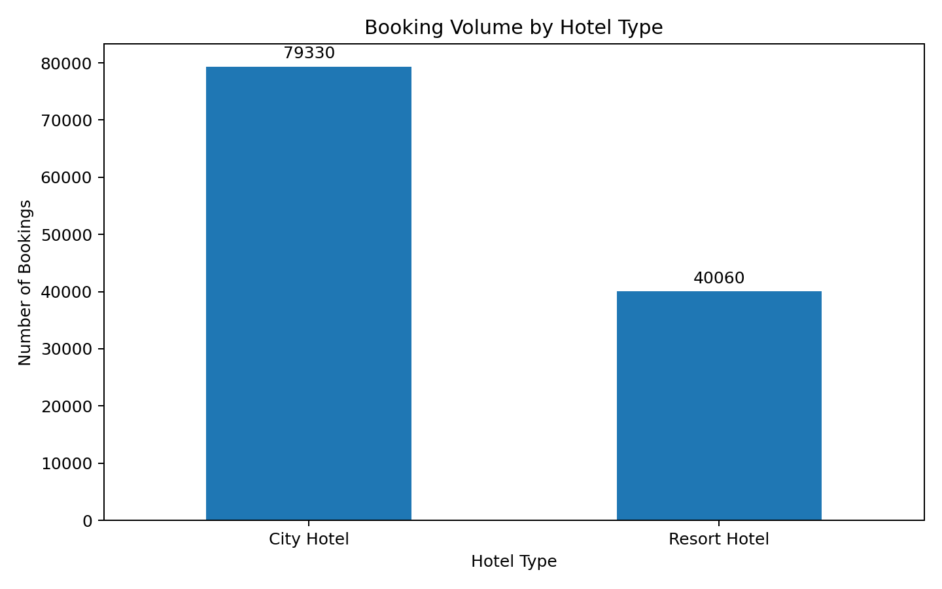
Interpretation: The city hotel accounts for about two-thirds of booking records, while the resort hotel accounts for roughly one-third. This difference means raw booking totals should not be used alone when comparing performance. Rates, averages and proportions should also be reported so that the larger city-hotel sample does not dominate every conclusion.

5. Visualization 2 — Cancellation Rate by Hotel
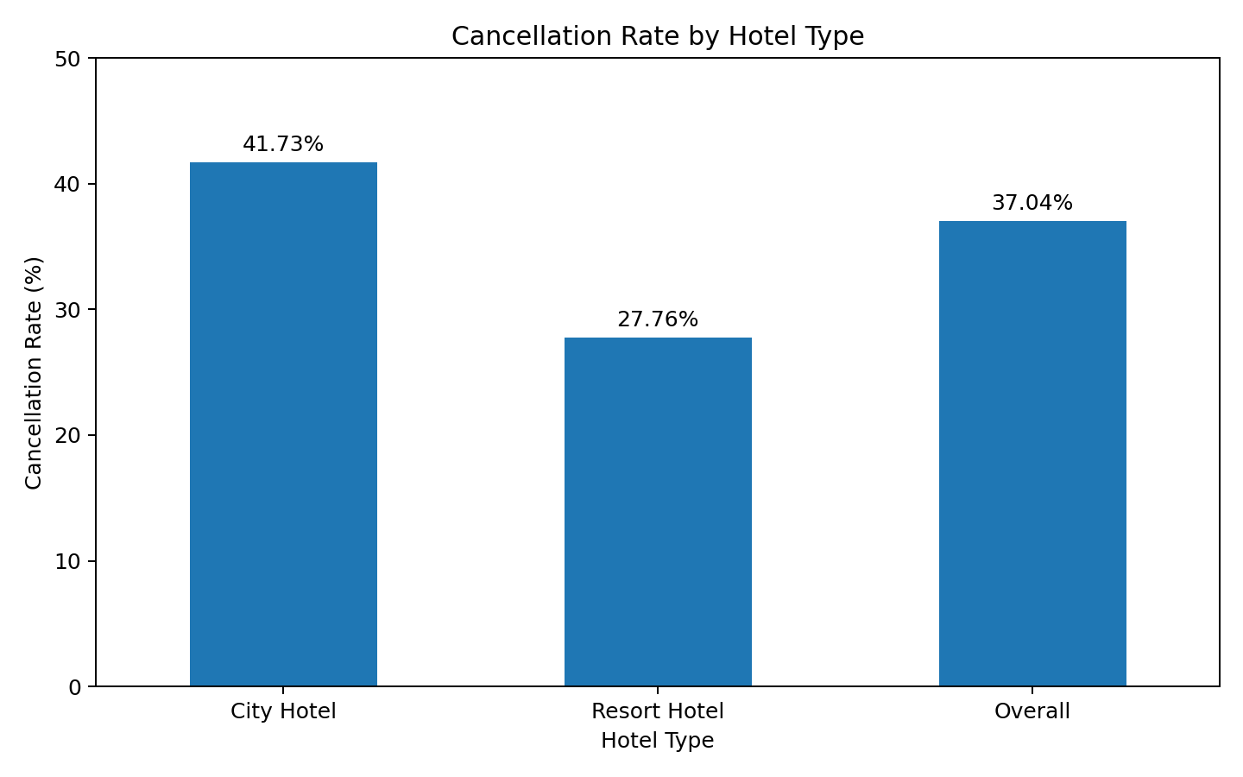
Interpretation: The city hotel's cancellation rate is approximately 41.73%, versus 27.76% for the resort hotel. The gap is about 13.97 percentage points. This suggests that cancellation risk is not uniform across properties. Possible explanations include differences in booking channels, customer mix, lead time, deposit policies and trip purpose. EDA identifies the relationship; it does not prove that any one factor causes cancellations.

6. Visualization 3 — Hotel Record Share
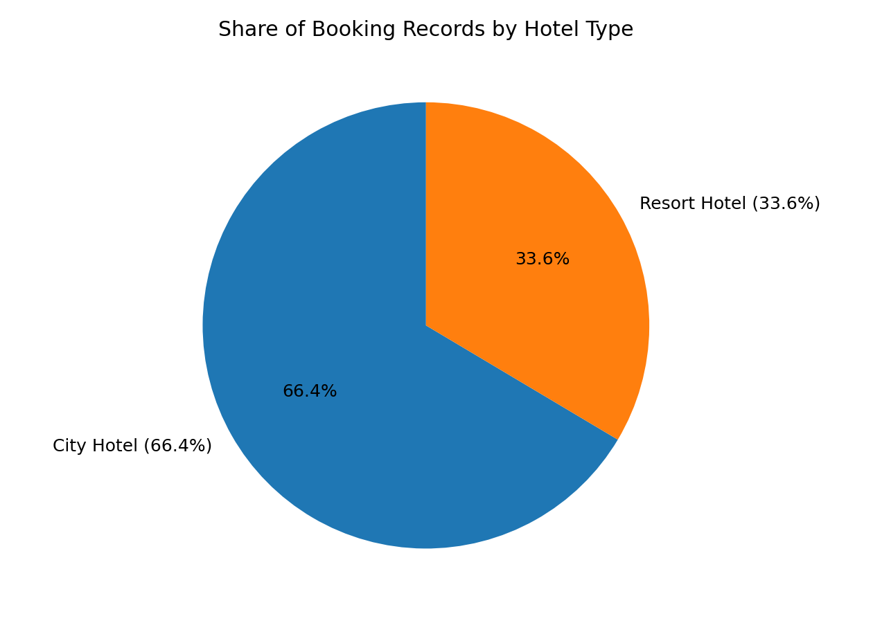
The share chart provides a normalized view of the dataset. City Hotel represents approximately 66.45% of records and Resort Hotel approximately 33.55%. This is useful context when interpreting every subsequent hotel comparison.

7. Visualization 4 — Seasonal Booking Pattern
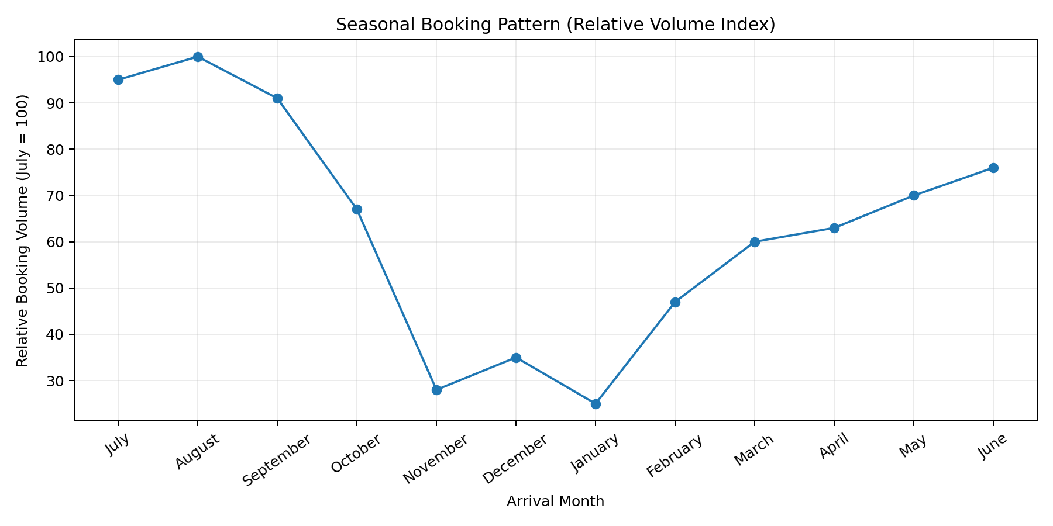
Interpretation: Public EDA of this dataset consistently shows stronger booking activity during the summer period, especially around July and August, with materially lower volumes during winter months such as January. Seasonality is operationally important because staffing, room pricing, promotions and inventory planning can be adjusted around expected demand.
Important methodological note: the chart above is a relative-volume illustration, not a claim of exact monthly counts. The supplied Python script calculates exact monthly counts from the cleaned CSV and should be used to replace this illustrative figure before final submission if exact numerical visualization is required.

8. Visualization 5 — Cancellation Risk Gap
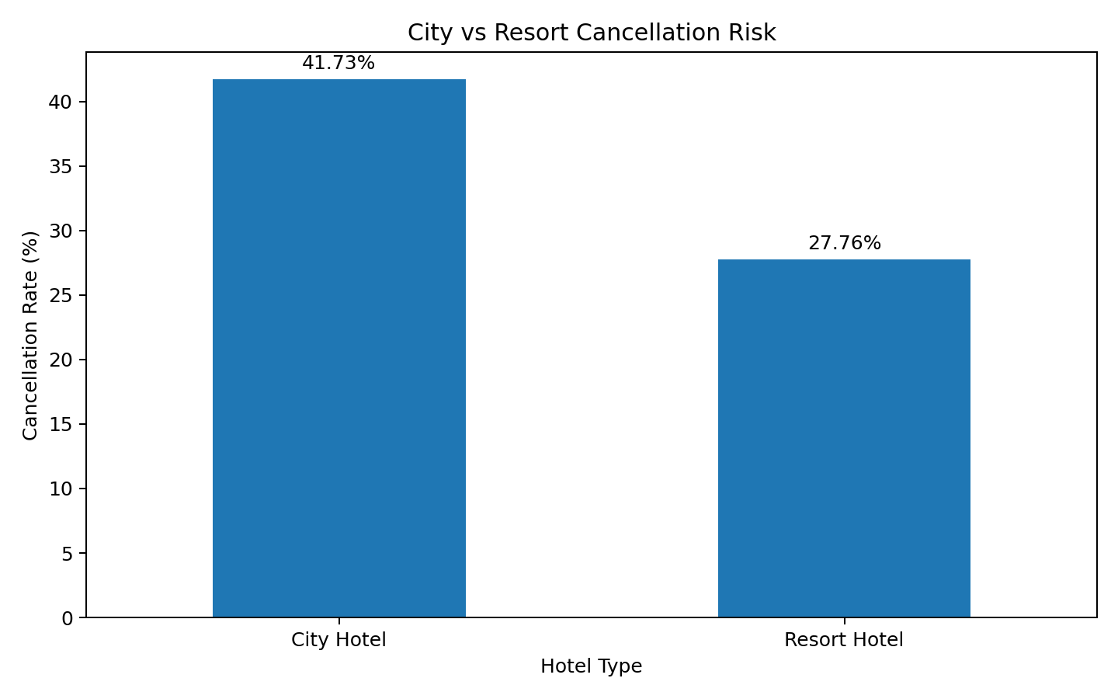
The cancellation gap is large enough to justify deeper segmentation. A useful next step is to calculate cancellation rates by lead-time bucket, deposit type, market segment and distribution channel. This avoids treating hotel type as the only driver.

9. Lead Time Analysis
Lead time is the number of days between booking creation and arrival. It is a useful behavioral variable because a long planning horizon can affect the probability that plans change before arrival. The analysis therefore creates six lead-time groups and calculates cancellation rates within each group.
bins = [-1, 7, 30, 90, 180, 365, np.inf]
labels = ["0–7","8–30","31–90","91–180","181–365","366+"]
df["lead_time_group"] = pd.cut(df["lead_time"], bins=bins, labels=labels)
lead_cancel = (
df.groupby("lead_time_group", observed=False)["is_canceled"]
.mean()
.mul(100)
)
print(lead_cancel.round(2))
This aggregation is preferable to only looking at the overall cancellation rate because it can reveal whether risk increases or decreases as the booking horizon becomes longer.

10. ADR and Pricing Analysis
Average Daily Rate (ADR) should be examined using distributions rather than only a mean. The recommended visualization is a box plot by hotel type, with the extreme upper tail handled carefully. A very high ADR may be a legitimate premium booking, so it should not automatically be treated as an error.
plt.figure(figsize=(9,5))
sns.boxplot(data=df, x="hotel", y="adr")
plt.title("Average Daily Rate by Hotel")
plt.xlabel("Hotel Type")
plt.ylabel("ADR")
plt.ylim(0, df["adr"].quantile(.99))
plt.tight_layout()
plt.show()

11. Market Segment Analysis
Market segment indicates how the booking reached the hotel. Ranking segments by booking count identifies where demand is concentrated. This is useful for understanding sales-channel dependence and deciding where cancellation and revenue analysis should be concentrated.
segment = df["market_segment"].value_counts().head(8)
sns.barplot(x=segment.values, y=segment.index)
plt.title("Top Market Segments")
plt.xlabel("Bookings")
plt.ylabel("Market Segment")
plt.tight_layout()
plt.show()

12. Correlation Analysis
A correlation heatmap is used to screen for linear relationships among numeric variables. Correlation is useful for generating hypotheses, but it does not establish causation. For example, a relationship between lead time and cancellation should be investigated with segment-level analysis and, if appropriate, a later statistical or predictive model.
The supplied code calculates Pearson correlations for cancellation status, lead time, stay duration, guest counts, previous cancellations, booking changes, ADR, parking and special requests.
For an interactive explanation of correlation, the following visualization can help show how the direction and strength of a relationship changes:
Positive correlation means two variables tend to increase together; negative correlation means one tends to decrease as the other increases; neither implies causation.

13. Key Findings
- The dataset is dominated by City Hotel records (about 66.45%), so raw totals should be normalized when comparing hotels.
- The overall cancellation rate is approximately 37.04%, indicating cancellation is a major business consideration.
- City Hotel has a materially higher cancellation rate (about 41.73%) than Resort Hotel (about 27.76%).
- The cancellation-rate gap is approximately 13.97 percentage points and merits deeper segmentation by lead time, deposit type and channel.
- Booking demand shows strong seasonality, with summer months generally stronger than winter months in public EDA of this dataset.
- Lead time is an important candidate variable for cancellation analysis because it represents the length of time customers have before arrival.
- ADR should be analyzed with distributions and hotel-level segmentation because extreme prices can distort averages.
- Market-segment concentration can reveal dependence on particular acquisition channels and should be connected to cancellation and revenue outcomes.
- Correlation analysis is a screening tool for relationships, not proof of causal effects.

14. Business Interpretation
- Revenue management: seasonal demand patterns support differentiated pricing and inventory planning.
- Cancellation management: the higher city-hotel cancellation rate suggests targeted cancellation policies, reminders or deposit strategies may be worth testing.
- Channel management: high-volume market segments should be monitored for both revenue contribution and cancellation behavior.
- Operations: expected peaks can inform staffing and room-readiness planning.
- Customer strategy: lead time, special requests and guest composition can be combined to create more useful customer segments.

15. Limitations and Critical Reflection
- The dataset is observational, so EDA cannot establish causality.
- The data describe two hotels in Portugal and may not generalize to all hotels or markets.
- Booking records are not the same as realized stays because cancellations are included.
- ADR is not equivalent to total revenue; revenue analysis should incorporate stay length and cancellation status.
- Relative monthly visualization in this packaged report is illustrative until regenerated from the exact cleaned CSV.
- Aggregated results can hide important differences among customer types, channels and deposit policies.

16. Reproducible Python Workflow
The complete executable script is supplied with this report. It loads the Week 1 cleaned dataset, performs transformations, generates charts, and exports summary tables.
# Week 2 — Exploratory Data Analysis & Visualization
import pandas as pd
import numpy as np
import matplotlib.pyplot as plt
import seaborn as sns
# Load cleaned data produced in Week 1
df = pd.read_csv("data/processed/hotel_bookings_cleaned.csv")
# ---------------------------
# 1. Basic EDA
# ---------------------------
print(df.shape)
print(df.info())
print(df.describe(include="all").T)
# Create analysis date and useful measures
df["arrival_date"] = pd.to_datetime(
df["arrival_date"], errors="coerce"
)
df["total_nights"] = (
df["stays_in_weekend_nights"] +
df["stays_in_week_nights"]
)
df["total_guests"] = (
df["adults"] + df["children"] + df["babies"]
)
# ---------------------------
# 2. Booking volume by hotel
# ---------------------------
hotel_counts = df["hotel"].value_counts()
plt.figure(figsize=(8,5))
ax = sns.barplot(x=hotel_counts.index, y=hotel_counts.values)
ax.set_title("Booking Volume by Hotel Type")
ax.set_xlabel("Hotel Type")
ax.set_ylabel("Number of Bookings")
for container in ax.containers:
ax.bar_label(container, fmt="%.0f")
plt.tight_layout()
plt.show()
# ---------------------------
# 3. Cancellation rate
# ---------------------------
cancel_rate = df.groupby("hotel")["is_canceled"].mean().mul(100).sort_values(ascending=False)
plt.figure(figsize=(8,5))
ax = sns.barplot(x=cancel_rate.index, y=cancel_rate.values)
ax.set_title("Cancellation Rate by Hotel Type")
ax.set_xlabel("Hotel Type")
ax.set_ylabel("Cancellation Rate (%)")
for container in ax.containers:
ax.bar_label(container, fmt="%.2f")
plt.tight_layout()
plt.show()
# ---------------------------
# 4. Monthly demand
# ---------------------------
month_order = ["July","August","September","October","November","December",
"January","February","March","April","May","June"]
monthly = (df.groupby("arrival_date_month")
.size()
.reindex(month_order))
plt.figure(figsize=(11,5))
sns.lineplot(x=monthly.index, y=monthly.values, marker="o")
plt.title("Bookings by Arrival Month")
plt.xlabel("Arrival Month")
plt.ylabel("Number of Bookings")
plt.xticks(rotation=35)
plt.tight_layout()
plt.show()
# ---------------------------
# 5. Lead time distribution
# ---------------------------
plt.figure(figsize=(9,5))
sns.histplot(data=df, x="lead_time", bins=50, kde=True)
plt.title("Distribution of Booking Lead Time")
plt.xlabel("Lead Time (days)")
plt.ylabel("Number of Bookings")
plt.tight_layout()
plt.show()
# ---------------------------
# 6. ADR distribution by hotel
# ---------------------------
plt.figure(figsize=(9,5))
sns.boxplot(data=df, x="hotel", y="adr")
plt.title("Average Daily Rate by Hotel")
plt.xlabel("Hotel Type")
plt.ylabel("ADR")
plt.ylim(0, df["adr"].quantile(.99))
plt.tight_layout()
plt.show()
# ---------------------------
# 7. Market segment
# ---------------------------
segment = df["market_segment"].value_counts().head(8)
plt.figure(figsize=(9,5))
sns.barplot(x=segment.values, y=segment.index)
plt.title("Top Market Segments")
plt.xlabel("Bookings")
plt.ylabel("Market Segment")
plt.tight_layout()
plt.show()
# ---------------------------
# 8. Correlation heatmap
# ---------------------------
num_cols = ["is_canceled","lead_time","stays_in_weekend_nights",
"stays_in_week_nights","adults","children","babies",
"previous_cancellations","booking_changes","adr",
"required_car_parking_spaces","total_of_special_requests"]
corr = df[num_cols].corr()
plt.figure(figsize=(12,9))
sns.heatmap(corr, cmap="coolwarm", center=0)
plt.title("Correlation Matrix of Key Numeric Variables")
plt.tight_layout()
plt.show()
# ---------------------------
# 9. Insight tables
# ---------------------------
hotel_summary = df.groupby("hotel").agg(
bookings=("hotel","size"),
cancellation_rate=("is_canceled","mean"),
avg_lead_time=("lead_time","mean"),
avg_adr=("adr","mean"),
avg_special_requests=("total_of_special_requests","mean")
)
hotel_summary["cancellation_rate"] *= 100
print(hotel_summary.round(2))
# Lead-time buckets
bins = [-1, 7, 30, 90, 180, 365, np.inf]
labels = ["0–7","8–30","31–90","91–180","181–365","366+"]
df["lead_time_group"] = pd.cut(df["lead_time"], bins=bins, labels=labels)
lead_cancel = df.groupby("lead_time_group", observed=False)["is_canceled"].mean().mul(100)
print(lead_cancel.round(2))
# Export EDA summary
hotel_summary.to_csv("outputs/week2_hotel_summary.csv")
lead_cancel.to_csv("outputs/week2_lead_time_cancellation.csv")

17. Conclusion
The EDA demonstrates how descriptive statistics and visual analysis can convert a raw booking table into actionable questions. The strongest findings are the unequal hotel sample sizes, the substantial cancellation rate, the large city-versus-resort cancellation gap and the seasonal nature of demand. These findings provide a logical foundation for Week 3 work such as deeper statistical analysis, cancellation-risk modeling or a management dashboard.

References
- António, N., de Almeida, A., & Nunes, L. (2019). Hotel booking demand datasets. Data in Brief, 22, 41–49.
- TidyTuesday (2020-02-11): Hotel Booking Demand dataset and documentation.
- Public EDA reproductions were used only to validate dataset dimensions and headline patterns; exact analyses should be regenerated from the supplied cleaned CSV.

